1.
A Project Report On

Electricity Bill Management System

Submitted in partial fulfillment of the requirement for the BCA Semester-4 Python Programming Subject Final Examination.
BACHELOROFCOMPUTER APPLICATIONS
(B.C.A.)

Academic Year 2025 – 26

Neish kamani - (92400527077)

Internal Guide
Prof. Amit Gohel



Rajkot-Morbi Road, At & PO : Gauridad, Rajkot 360 003. Gujarat. India.

CONTENTS

Chapters | Particulars | Page No.
1 | SYNOPSIS | 1
2 | PREAMBLE | 1
2.1 | General Introduction
2.2 | Statement of Problem
2.3 | Objective and Scope of the Study
2.4 | Module Description with functionality
3 | SYSTEM DESIGN AND DEVELOPMENT | 5
3.1 | Data Flow Diagram (DFD)
3.2 | Table Structure
3.3 | Menu Design
3.4 | Screen Design (Screen shots with short description)
4 | CONCLUSION | 15
5 | LEARNING DURING PROJECT WORK | 15
6 | BIBLIOGRAPHY | 15
6.1 | Online References
6.2 | Offline References

1: SYNOPSIS
Electricity Bill Management System is a software application developed using Python and Tkinter. This system automates the electricity billing process and reduces the need for manual calculations.
In this project, the user can create new bills, view and search previous bills, update customer details, and manage deleted bills using a recycle bin. The system also provides data visualization through graphs.
The data is stored in JSON files, making the system simple, efficient, and easy to manage.

2: PREAMBLE

2.1 General Introduction
In traditional electricity billing systems, all work is carried out manually, which is time-consuming and prone to errors. This project provides a computerized solution with a user-friendly graphical interface (GUI).
The system is developed using the Python programming language and the Tkinter library.

2.2 Statement of Problem
The manual electricity billing system has the following problems:
- Calculation errors
- Risk of data loss
- Time-consuming process
- Difficulty in tracking bills
This project helps to overcome all these problems.

2.3 Objectives and Scope
Objectives:
- To automate the billing process
- To provide a user-friendly GUI
- To store customer information securely
- To provide graphical representation of data
Scope:
- Can be used in small electricity billing offices
- Useful for educational purposes
- Can be extended with database integration in the future

2.4 Functionality of Modules
1. Create Bill Module
- Takes customer information
- Calculates units
- Automatically generates the bill
2. View Bill Module
- Displays all bills
- Allows opening a specific bill
3. Search Module
- Searches bills using customer number
4. Edit Module
- Updates customer information
5. Delete Module
- Deletes the bill and moves it to the recycle bin
6. Recycle Bin Module
- Restores deleted bills
- Provides a permanent delete option
7. Graph Module
- Bar graph (Electricity vs Solar)
- Pie chart (Charges distribution)

3: SYSTEM DESIGN AND DEVELOPMENT

3.1 Data Flow Diagram (DFD)
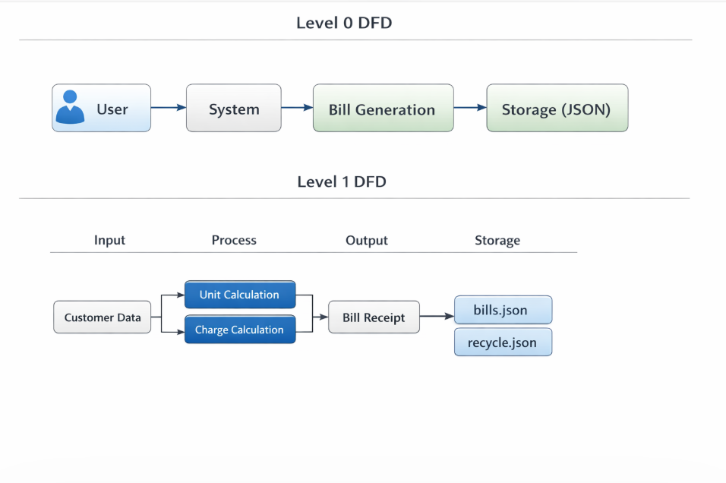

3.2 Table Structure (JSON Format)
- bill_no – Bill number
- customer_no – Customer ID
- name – Customer name
- phone – Phone number
- address – Address
- units – Total units
- solar_units – Solar units
- net_units – Net units
- energy_charge – Energy cost
- fixed_charge – Fixed charge
- gst – GST amount
- total – Total bill amount

3.3 Menu Design
The main dashboard includes the following options:
- Create Bill
- View Bills
- Search Bill
- Edit Bill
- Delete Bill
- Recycle Bin
- Graphs
- Exit

3.4 Screen Design
1. Dashboard Screen
The main menu contains all options in the form of buttons.
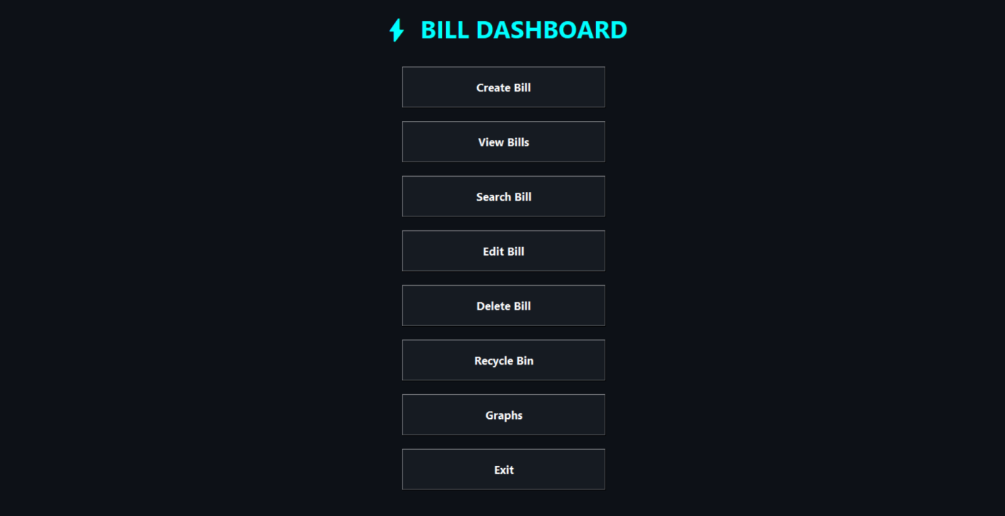

2. Create Bill Screen
This screen is used to enter customer details and meter readings.
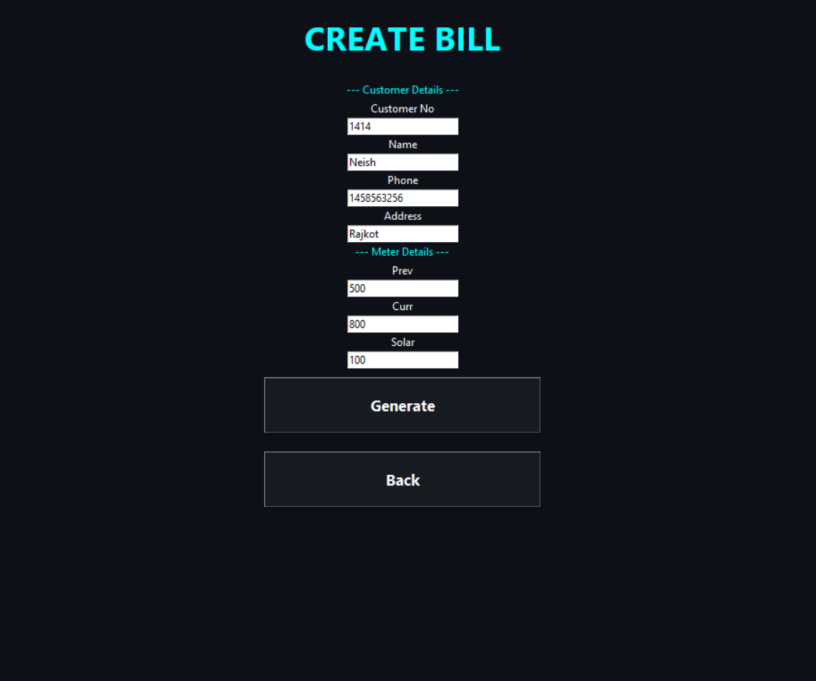

3. Receipt Screen
The generated bill is displayed in a proper format.
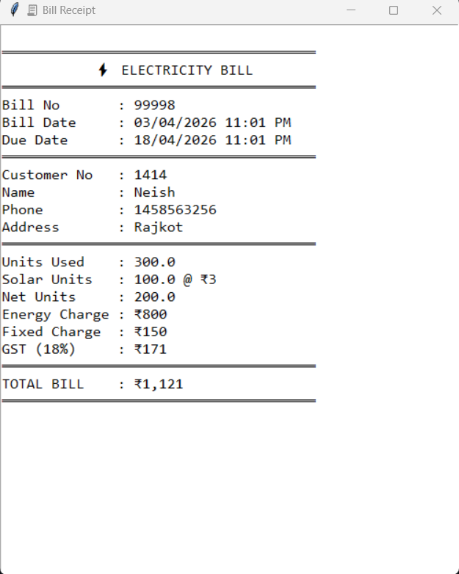

4. View Bills Screen
All bills are displayed in a list format.
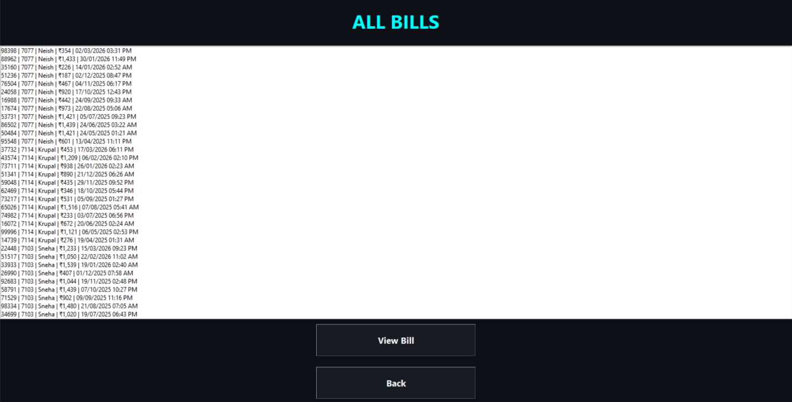

5. Search Bill
A specific bill can be searched using the customer number.
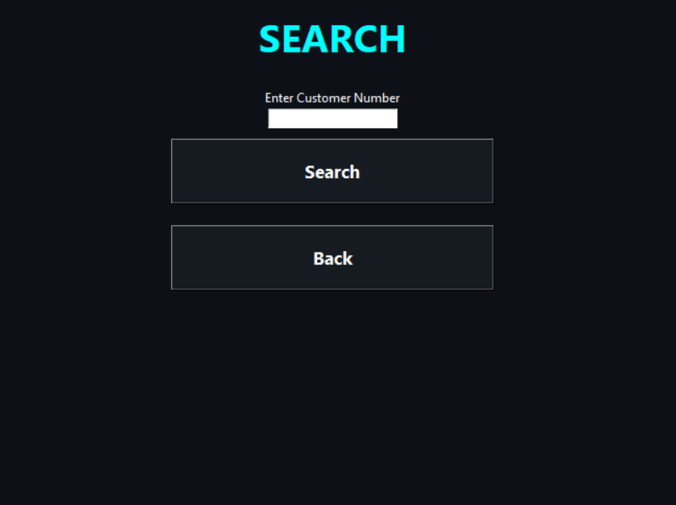

6. Edit Bill
You can change the Name, Address, and Phone Number in the bill.

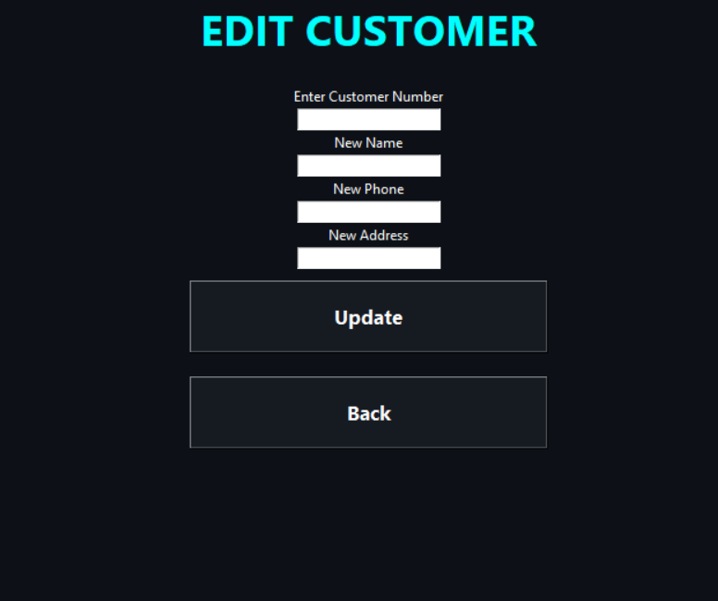

7. Delete Bill

You can delete the bill.

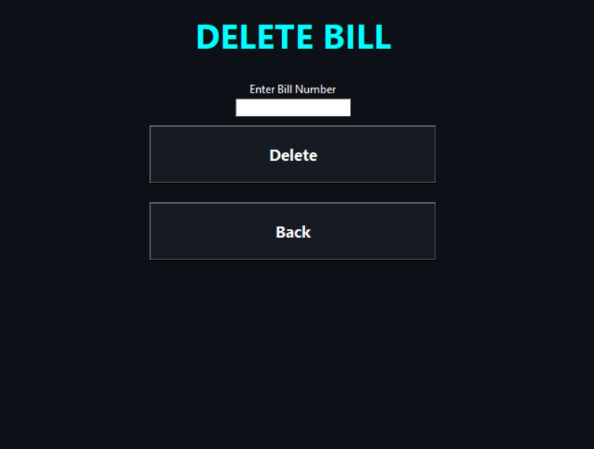

8. Recycle Bin
You can restore the bill from the recycle bin or permanently delete it.

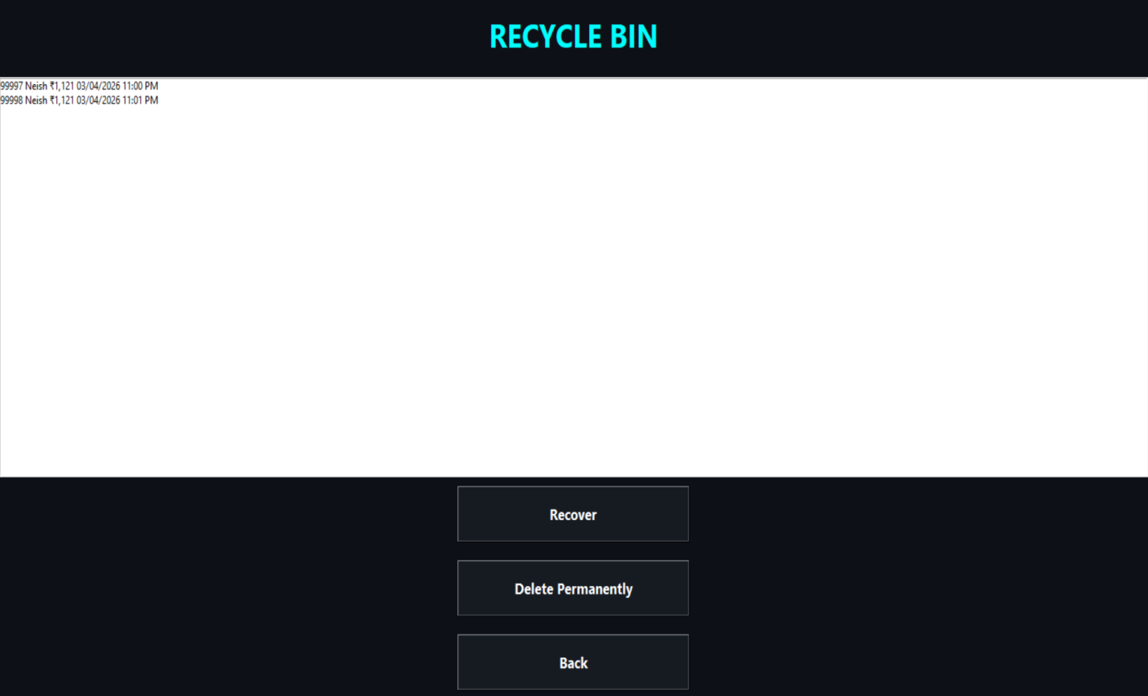

9. Graphs

Data is represented using bar graphs and pie charts.

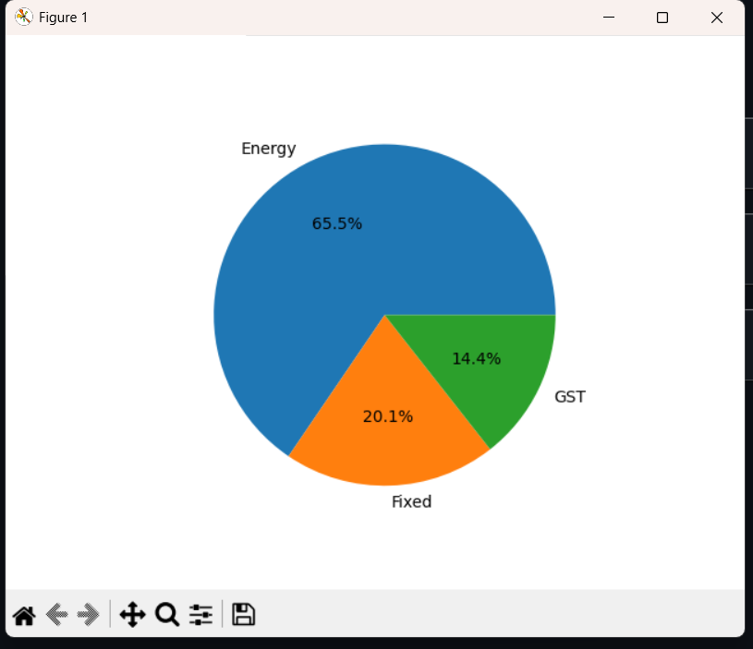

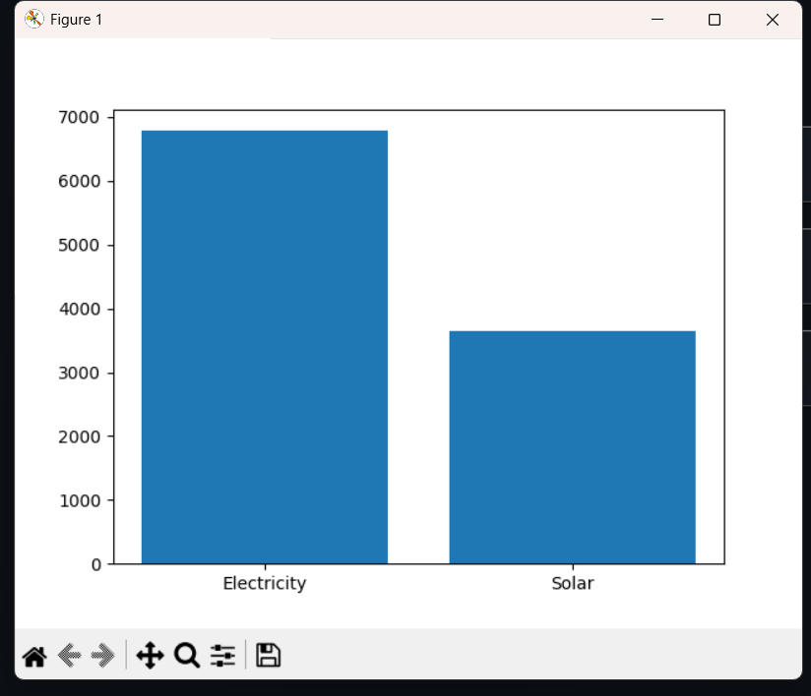

4: CONCLUSION
This project successfully automates the electricity billing system. It provides an easy-to-use GUI along with an accurate calculation system, making it efficient and reliable.
It reduces paperwork and offers a fast and dependable billing process.

5: LEARNING
During this project, the following skills were learned:
- Python GUI development (Tkinter)
- File handling using JSON
- Data visualization using Matplotlib
- Error handling
- Real-world problem solving

6: BIBLIOGRAPHY
Online References:
- https://docs.python.org
- https://www.geeksforgeeks.org
- https://stackoverflow.com
Offline References:
- Python Programming Book
- College Notes

FIGURE INDEX

Sr. No. | Figure No. | Particulars | Page No.
1 | Fig 3.1 | Main Dashboard GUI | 6
2 | Fig 3.2 | Create Bill Screen | 7
3 | Fig 3.3 | Bill Receipt Popup | 8
4 | Fig 3.4 | View Bills Screen | 9
5 | Fig 3.5 | Search Bill Screen | 10
6 | Fig 3.6 | Edit Customer Details Screen | 11
7 | Fig 3.7 | Delete Bill Screen | 12
8 | Fig 3.8 | Recycle Bin Screen | 13
9 | Fig 3.9 | Data Visualization (Bar Graph & Pie Chart) | 14

TABLE INDEX

Sr. No. | Table No. | Particulars | Page No.
1 | Table 3.1 | Bill JSON Data Structure
2 | Table 3.2 | Customer Details Fields
3 | Table 3.3 | Meter Input Data (Prev, Curr, Solar)
4 | Table 3.4 | Electricity Unit Calculation Logi
5 | Table 3.5 | Energy Charge Calculation Slab
6 | Table 3.6 | GST and Fixed Charge Calculation
7 | Table 3.7 | Final Bill Structure (Total Calculation)

